Hunterdon Health & Wellness Center - Clinton, NJ
WaterART Certifications & Workshops 2020

HOW TO REGISTER - All registrations via WaterART Fitness

MAIL: WaterART Fitness International Inc. 210 South 8th St, Lewiston NY
PHONE: (with Credit Card) TOLL FREE 1 866 5 GET WET (1-866-5-438-938)
ONLINE: www.waterart.org

ALL REGISTRATIONS VIA WATERART Clinton, NJ
NAME: ___________________________________________________WaterART Professionals#:_____________________
ADDRESS:___________________________________________________________________________________________
CITY: ________________________________________________STATE: ____________ZIP CODE: ___________________
BEST PHONE #: _____________________________EMAIL:_________________________________________________
Registration For _______________________________________________________TOTAL $ ___________________
Please let us know if the MAILING ADDRESS OR NAME ON CARD (IF DIFFERENT THAN ABOVE) _______________________________________________________________________________________________
Visa or MasterCard #: ______________________________________________________Exp. Date: _______/______
3 digit authenticity code _____________Signature: ______________________________________________________
Please Indicate Discount Code if you are a Staff at host facility_____________________________________________

EARLY BIRD pricing is **TWO WEEKS** prior to the event
SENIOR H2O INSTRUCTOR CERTIFICATION  Saturday & Sunday, February 1 & 2, 2020  Fee includes: 16 hours of training, Comprehensive Manual with study guide questions & answers, Laminated Cards, online streaming of educational DVDs , Exam process and Certificate of course completion. E-Certification diploma and online profile when successful with exam. | Early Bird WP Member/Staff Rate $289.00  Early Bird Regular Rate $309.00  Regular WP Member/Staff Rate $309.00  Regular Rate $329.00
SHALLOW & DEEP H2O INSTRUCTOR CERTIFICATION  Saturday & Sunday, April 4 & 5, 2020  Saturday & Sunday, June 13 & 14, 2020  Fee includes: 16 hours of training, Comprehensive Manual with study guide questions & answers, Laminated Cards, online streaming of educational DVDs, Exam process and Certificate of course completion. E-Certification diploma and online profile when successful with exam. | Early Bird WP Member/Staff Rate $289.00  Early Bird Regular Rate $309.00  Regular WP Member/Staff Rate $309.00  Regular Rate $329.00
WALKING H2O INSTRUCTOR CERTIFICATION  Saturday, September 12, 2020  Fee includes: 8 hours of training, Comprehensive Manual with study guide questions & answers, Laminated Cards, online streaming of educational DVDs, Exam process and Certificate of course completion. E-Certification diploma and online profile when successful with exam. | Early Bird WP Member/Staff Rate $289.00  Early Bird Regular Rate $309.00  Regular WP Member/Staff Rate $309.00  Regular Rate $329.00
MIND BODY H2O INSTRUCTOR CERTIFICATION  Sunday, September 13, 2020  Fee includes: 8 hours of training, Comprehensive Manual with study guide questions & answers, Laminated Cards, online streaming of educational DVDs, Exam process and Certificate of course completion. E-Certification diploma and online profile when successful with exam. | Early Bird WP Member/Staff Rate $289.00  Early Bird Regular Rate $309.00  Regular WP Member/Staff Rate $309.00  Regular Rate $329.00
ARTHRITIS H2O INSTRUCTOR CERTIFICATION  Saturday, November 14, 2020  Fee includes: 8 hours of training, Comprehensive Manual with study guide questions & answers, Laminated Cards, online streaming of educational DVDs, Exam process and Certificate of course completion. E-Certification diploma and online profile when successful with exam. | Early Bird WP Member/Staff Rate $289.00  Early Bird Regular Rate $309.00  Regular WP Member/Staff Rate $309.00  Regular Rate $329.00
DEEP H2O INSTRUCTOR CERTIFICATION  Sunday, November 15, 2020  Fee includes: 8 hours of training, Comprehensive Manual with study guide questions & answers, Laminated Cards, online streaming of educational DVDs, Exam process and Certificate of course completion. E-Certification diploma and online profile when successful with exam. | Early Bird WP Member/Staff Rate $289.00  Early Bird Regular Rate $309.00  Regular WP Member/Staff Rate $309.00  Regular Rate $329.00
8.0 HOUR CEC WORKSHOPS  Seniors “Fun”ctional Fitness – Saturday, February 1, 2020  A Variety of Workshops – Sunday, February 2, 2020  Aquatic Noodle Boot Camp – Saturday, April 4, 2020  Water Pilates & Core Training – Sunday, April 5, 2020  Shallow Splash H2O – Saturday, June 13, 2020  Aquatic Equipment Toolbox – Sunday, June 14, 2020  Walking H2O – Saturday, September 12, 2020  Mindful Movements – Sunday, September 13, 2020  Arthritis H2O – Sunday, November 14, 2020  Deep H2O Splash – Sunday, November 15, 2020  Fee includes: 8 hours of onsite training (theory & practical pool session), WaterART Handouts, Certificate of course completion: 8 hours for WaterART, ACE, YMCA, & AEA (You may petition other organizations). | Early Bird WP Member/Staff Rate $119.00  Early Bird Regular Rate $139.00  Regular WP Member/Staff Rate $139.00  Regular Rate $159.00
16 HOUR CEC RE-CERTIFICATION WORKSHOP  Saturday & Sunday, February 1 & 2, 2020  Saturday & Sunday, April 4 & 5, 2020  Saturday & Sunday, June 13 & 14, 2020  Saturday & Sunday, November 14 & 15, 2020  Fee includes: 16 hours of onsite training, Workshop handouts, Updated Certification Diploma & online profile (for two years from your current expiry), Certificate of course completion and Continuing education credits. | Early Bird WP Member/Staff Rate $219.00  Early Bird Regular Rate $239.00  Regular WP Member/Staff Rate $239.00  Regular Rate $259.00  $20.00 Late Fee (expired less than one year from expiry date)  Choose WaterART Mitts Size  S M L XL

CANCELLATION & REFUND POLICY: We do not offer refunds on event registrations. If you are unable to attend a course or workshop after you have registered and paid you will have the choice of: 1) Receive the complete correspondence program courses or the appropriate course materials for the workshop without a certificate of course completion OR 2) Attend another training course or workshop, of equal or lesser value, within a 6 month time period from your original event. If you cannot attend event, please be sure to submit written cancellation 48 hours prior to event date (email info@waterart.org to ensure we receive your cancellation). Please note that we will charge a $25.00 rebooking fee if you decide to move your event to a different date. Please arrive about 15 minutes early to fill in the Waiver of Liability & Par-Q information. All materials not shipped in advance will be picked up on the day of the training.

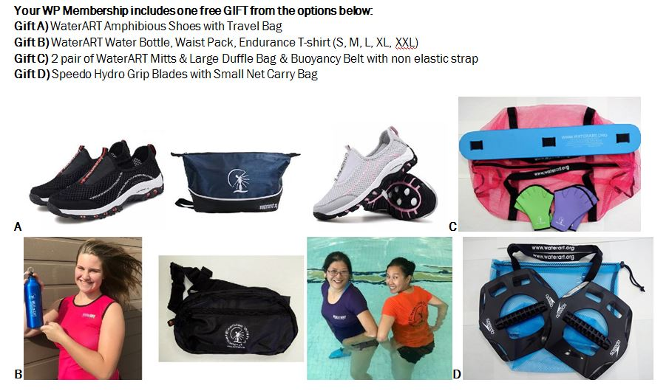
NEW WP MEMBERSHIP $75.00/ year WP RENEWAL $65.00/ year $75.00/ year CHOOSE FREE GIFT A B C D

